聚丙烯
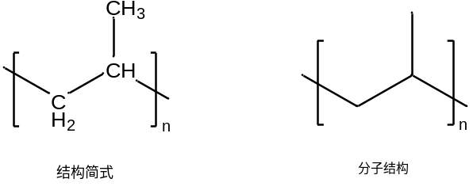
聚丙烯（Polypropylene，简称PP）是一种半结晶的热塑性塑料。具有较高的耐冲击性，机械性质强韧，抗多种有机溶剂和酸碱腐蚀。在工业界有广泛的应用，是平常常见的高分子材料之一。(Kakooei, Akil et al. 2012)
1954年，意大利化学家朱利奥·纳塔（Giulio Natta）首次合成了聚丙烯。同年，Ziegler和Natta发明了Ziergler-Natta催化剂并制成结晶性聚丙烯，具有较高的立构规整性，称为全同立构聚丙烯或等规聚丙烯(Castonguay and Rappe 1992)。这一研究成果在聚合领域中开拓了新的方向，给聚丙烯大规模的工业化生产和广泛应用奠定了基础。1957年，意大利的蒙特卡提尼公司首先实现了聚丙烯工业化生产。
主要用途
主要用于各种长、短丙纶纤维的生产，用于生产聚丙烯编织袋、打包袋、注塑制品等用于生产电器、电讯、灯饰、照明设备及电视机的阻燃零部件(Guidetti, Rigosi et al. 1996)。

合成制备方法一
连续流丙烯酸甲酯还原法^{①}

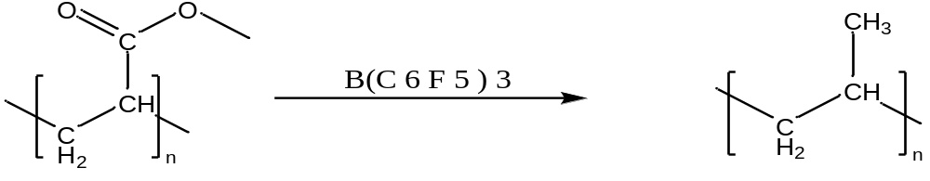
图1

在连续流封闭反应釜中通过在硅烷还原剂存在下利用B(C6F5)3催化脱氧，消除聚（丙烯酸甲酯）中的侧酯有效地留下了具有甲基侧链的线性烃聚合物，即聚丙烯(Murata, Hirano et al. 2002)。

合成方法二
溶液聚合法^{④}
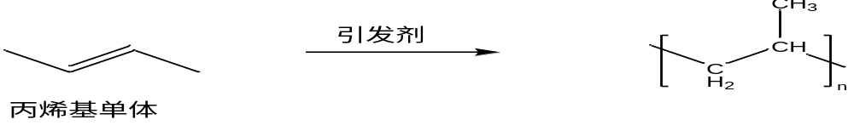
图2
该方法是将丙烯基单体溶解在适当的溶剂二氯甲烷/四氢呋喃/甲醇等溶剂中，加入引发剂偶氮二异丁腈/偶氮二异庚腈/偶氮二异丁酸二甲酯等，通过引发剂起始聚合过程，形成聚丙烯(Giavarini, De Filippis et al. 1996)

两种合成方法对比分析
连续流丙烯酸甲酯还原法，反应需要加入还原剂，反应处理起来简单，反应时间比较短，反应比较干净，但是在反应得过程中需要高压，还原剂比较活泼，操作比较严格(De Rosa, Auriemma et al. 2004)。
溶液聚合法，反应只需要加入适当的溶剂，加入引发剂，加入丙烯基单体即可，但是聚合得时间比较漫长一些。此外，石油烯基法、气相聚合法也是常见的聚丙烯合成方法(Jeon, Kim et al. 2019)。

工业化生产得利弊
连续流丙烯酸甲酯还原法
优点：在反应体系中，将催化剂直接分散在液相丙烯中进行丙烯液相本体聚合反应。聚合物从液相丙烯中不断析出，以细颗粒状悬浮在液相丙烯中。随着反应时间的增长，聚合物颗粒在液相丙烯中的浓度增高。当丙烯转化率达到一定程度时，经闪蒸回收未聚合的丙烯单体，即得到粉料聚丙烯产品(Xu and Guo 2010)。
缺点：聚合反应热难以控制，容易产生局部过热，导致产品质量不稳定(Mei, Beccarini et al. 2009)。

溶液聚合法
优点：使用高沸点直链烃作溶剂，在高于聚丙烯熔点的温度下操作，所得聚合物全部溶解在溶剂中呈均相分布(Chung and Rhubright 1991)。
缺点：高温气提方法蒸发脱除溶剂得熔融聚丙烯，再挤出造粒得粒料产品，生产过程中需要使用大量的溶剂，对环境造成一定的污染(Pang, Zhuang et al. 2010)。

聚丙烯的未来
根据中国报告大厅2024年3月29日的信息，未来聚丙烯市场的发展趋势如下：
一
新型应用领域增长：随着科技进步和消费需求变化，新型应用领域的开拓将为聚丙烯市场带来增长动力。例如，在包装、医疗器械、汽车零部件、建筑材料等领域的应用将不断扩大。
二
可持续发展需求：环保意识的提升促使聚丙烯行业向可持续发展方向转型。可降解聚丙烯等环保产品的需求增加，推动行业朝着更环保、循环经济的方向发展。
三
技术创新推动：在聚丙烯生产工艺、产品性能改进等方面的持续技术创新将提升行业竞争力，满足不断变化的市场需求

Castonguay, L. A. and A. K. Rappe (1992). "Ziegler-Natta catalysis. A theoretical study of the isotactic polymerization of propylene." Journal of the American Chemical Society 114(14): 5832-5842.

Chung, T. C. and D. Rhubright (1991). "Synthesis of functionalized polypropylene." Macromolecules 24(4): 970-972.

De Rosa, C., et al. (2004). "Comparison between Polymorphic Behaviors of Ziegler−Natta and Metallocene-Made Isotactic Polypropylene: The Role of the Distribution of Defects in the Polymer Chains." Macromolecules 37(4): 1441-1454.

Giavarini, C., et al. (1996). "Production of stable polypropylene-modified bitumens." Fuel 75(6): 681-686.
The use of polypropylene polymers and copolymers as modifiers for road bitumens appears promising. The problem of stability during storage for long periods at high temperatures can be solved by adding phosphorus compounds, especially polyphosphoric acid, which changes the bitumen structure from sol to gel. It is demonstrated that the stability of polymer-modified bitumens depends not only on the difference in density and viscosity between bitumen and polymer but also on bitumen structure.

Guidetti, G. P., et al. (1996). "The use of polypropylene in pipeline coatings." Progress in Organic Coatings 27(1): 79-85.
Despite the fact that the pipeline coating represents only about 5% of the total cost, the choice of the most effective coating is a key point to guarantee the life of the installed pipelines. Since the eighties, polypropylene copolymer coatings have been used for the protection of the external surface of on-shore and off shore pipelines. Polypropylene is one of the most suitable coatings when high mechanical properties (impact resistance, penetration resistance, etc.) and/or heat resistance are required. Polypropylene has also been used in ordinary pipelines giving advantages compared with the standard coatings, e.g. fusion bonded epoxy resin, coal tar enamel and polyethylene. New applications for polypropylene copolymers such as pipeline coatings have recently been developed, these include an insulating coating obtained with foamed polypropylene and an internal coating obtained by spraying a polypropylene adhesive powder.

Jeon, C., et al. (2019). "Synthesis of Polypropylene via Catalytic Deoxygenation of Poly(methyl acrylate)." ACS Macro Letters 8(9): 1172-1178.

Kakooei, S., et al. (2012). "The effects of polypropylene fibers on the properties of reinforced concrete structures." Construction and Building Materials 27(1): 73-77.
In this study, the results of polypropylene fibers reinforced concrete properties have been presented. The compressive strength, permeability and electric resistivity of concrete samples were studied. The concrete samples were made with different fibers amounts from 0 to 2kgm−3. Also, the samples fabricated with coral aggregate and siliceous aggregate were examined and compared. The samples with added polypropylene fibers of 1.5kgm−3 showed better results in comparison with the others. Moreover, coral aggregate concrete showed less electric resistivity and less compressive strength in comparison with samples fabricated of siliceous aggregates. It is concluded that the coral aggregates are not suitable for making concrete or using in concrete structures in the onshore atmosphere.

Mei, G., et al. (2009). "Recent Technical Advances in Polypropylene." Journal of Plastic Film & Sheeting 25(2): 95-113.
The Spherizone process technology, which is based on a multizone circulating reactor (MZCR), represents a significant innovation in polypropylene (PP) production. In comparison to traditional multi-step technologies, the MZCR provides a step change in the polymer homogeneity of the final product, obtained by continuously circulating the growing polymeric granules between two interrelated zones where different gas-phase compositions are realized. In addition to traditional Z-N catalysts, metallocene catalysts are also being introduced in PP manufacture: single-site catalysts allow differentiated products with outstanding property combinations. Due to its versatility and sustainability, PP continues to be utilized in a large range of applications. Innovative polymer structures featuring diverse comonomers exhibit improved properties (i.e., stiffness-impact balance, aesthetics, transparency, processability), which reinforce the capability of PP to replace traditional materials such as wood, paper, glass, and metals, as well as standard polymer products.

Murata, K., et al. (2002). "Basic study on a continuous flow reactor for thermal degradation of polymers." Journal of Analytical and Applied Pyrolysis 65(1): 71-90.
A continuous flow reactor for thermal degradation of polymer such as polyethylene (PE), polypropylene (PP) and polystyrene (PS) was operated at the feed rate of 0–1.5 kg h−1 in order to investigate the characteristics of the continuous flow operation and the thermal degradation behavior of polymers. Rate studies on thermal degradation of polymers were made at various temperatures and under a steady state. The activation energies, calculated on the basis of the rate of volatilization, were 221, 216 and 208 kJ mol−1 for thermal degradation of PE, PP and PS, respectively. These activation energies indicate that a chemical reaction takes a role of rate controlling step in this reactor system. By continuous flow operation, polymers were converted to the liquid product with high yield of 93.6–96.2, 96.1–99.1 and 99.9 wt.% for PE, PP and PS. The liquid products consisted of a wide spectrum of hydrocarbons distributed C4–C30. Thermal degradation by continuous flow operation is a suitable technique for converting plastic polymers into liquid hydrocarbons which could be used as feed stock materials. Based on the observed information, a macroscopic mechanism was proposed. The thermal degradation of polymers consists of two distinct reactions which simultaneously occur in the reactor. One is a random scission of links which causes a molecular weight reduction of the raw polymer, and the other is a chain-end scission of CC bonds, which causes the generation of the volatile product. The chain-end scission takes a place at the gas–liquid interface in the working reactor.

Pang, X., et al. (2010). "Polylactic acid (PLA): Research, development and industrialization." Biotechnology Journal 5(11): 1125-1136.
Abstract Polylactide (PLA) is a biodegradable, aliphatic polyester derived from lactic acid. It has similar mechanical properties to polyethylene terephthalate, but has a significantly lower maximum continuous use temperature. PLA products can be recycled after use either by remelting and processing the material a second time or by hydrolyzing to lactic acid, the basic chemical. In this review, the technologies for polymerization of the lactic acid and the comparison of physical, thermal and mechanical properties, biodegradability, and biocompatibility of the PLA and copolymers with other similar polymers are described.

Xu, J. and B.-H. Guo (2010). "Poly(butylene succinate) and its copolymers: Research, development and industrialization." Biotechnology Journal 5(11): 1149-1163.
Abstract Poly(butylene succinate) (PBS) and its copolymers are a family of biodegradable polymers with excellent biodegradability, thermoplastic processability and balanced mechanical properties. In this article, production of the monomers succinic acid and butanediol, synthesis, processing and properties of PBS and its copolymers are reviewed. The physical properties and biodegradation rate of PBS materials can be varied in a wide range through copolymerization with different types and various contents of monomers. PBS has a wide temperature window for thermoplastic processing, which makes the resin suitable for extrusion, injection molding, thermoforming and film blowing. Finally, we summarized industrialization and applications of PBS.

